Design principles & Patterns
Exercise 1: Implementing the Singleton Pattern
using System;
class Singleton
{
private static Singleton instance;
// Private Constructor
private Singleton()
{
Console.WriteLine("Singleton Instance Created");
}
// Method to get single instance
public static Singleton GetInstance()
{
if (instance == null)
{
instance = new Singleton();
}
return instance;
}
public void Display()
{
Console.WriteLine("Singleton Method Called");
}
}
class Program
{
static void Main(string[] args)
{
Singleton obj1 = Singleton.GetInstance();
Singleton obj2 = Singleton.GetInstance();

obj1.Display();
obj2.Display();
if (obj1 == obj2)
{
Console.WriteLine("Both objects are the same instance.");
}
else
{
Console.WriteLine("Different instances created.");
}
Console.ReadKey();
}
}
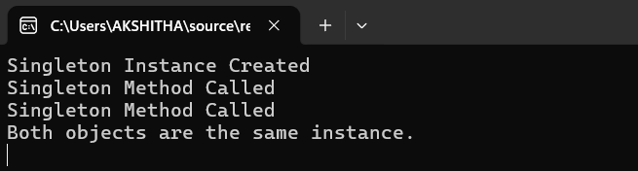
Exercise 2: E-commerce Platform Search Function
using System;
// Product Interface
interface IVehicle
{
void Show();
}
// Concrete Products
class Car : IVehicle
{
public void Show()
{
Console.WriteLine("Car Created");
}
}
class Bike : IVehicle
{
public void Show()
{
Console.WriteLine("Bike Created");
}
}
// Factory Class
class VehicleFactory
{
public static IVehicle GetVehicle(string type)
{
if (type.ToLower() == "car")
return new Car();

else if (type.ToLower() == "bike")
return new Bike();

else
return null;
}
}
// Main Class
class Program
{
static void Main(string[] args)
{
Console.Write("Enter Vehicle Type (Car/Bike): ");
string type = Console.ReadLine();

IVehicle vehicle = VehicleFactory.GetVehicle(type);

if (vehicle != null)
vehicle.Show();
else
Console.WriteLine("Invalid Vehicle Type");

Console.ReadKey();
}
}
